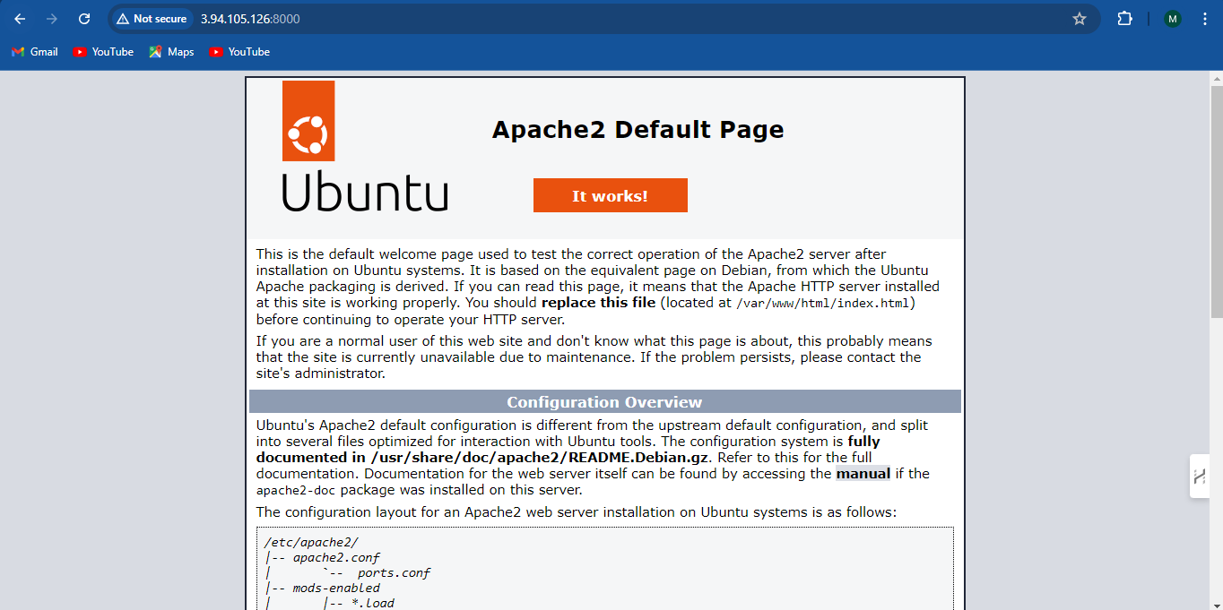

root@11394d47cb6c:/# history
1 apt-get install apache2
2 exit
3 history
4 exit
5 systemctl start apache2
6 service apache2 start
7 apt-get update
8 apt-get start apache2
9 apt-get install apache2 -y
10 apt-get start apache2
11 apt-get restart apache2
12 service apache2 start
13 exit
14 service apache2 status
15 exit
16 ls
17 cd /var
18 ls
19 cd /www
20 cd www
21 ls
22 cd html
23 ls
24 cat index.html
25 exit
26 /etc/apache2/sites-available/
27 cd /etc/apache2/sites-available/
28 ls
29 cat 000-default.conf
30 cat default-ssl.conf
31 nano ports.conf
32 vi ports.conf~
33 exit
34 service apache2 status
35 service apache2 start
36 service apache2 status
37 exit
38 Listen 8000
39 ~
40 Listen 8000
41 cd /etc/apache2
42 ls
43 cat ports.conf
44 nano ports.conf
45 apt-get update
46 apt-get install vim -y
47 vim ports.conf
48 cat ports.conf
49 exit
50 vi /etc/apache2/sites-available/000-default.conf
51 service apache2 restart
52 vi /etc/apache2/sites-available/000-default.conf
53 service apache2 restart
54 vim /etc/apache2/apache2.conf
55 service apache2 restart
56 exit
57 history

Server commands
48 sudo docker container ls
49 sudo docker exec -it f7514247de15 /bin/bash
50 # Inside the container shell, check the web server
51 # Example for Apache
52 service apache2 status
53 # Example for Nginx
54 service nginx status
55 sudo docker exec -it f7514247de15 /bin/bash
56 sudo docker commit f7514247de15 mewimg
57 sudo docker images
58 sudo docker run -itd -p 8000:8000 mewimg
59 sudo docker container ls
60 sudo docker exec -it 11394d47cb6c
61 sudo docker exec -it 11394d47cb6c /bin/bah
62 sudo docker exec -it 11394d47cb6c /bin/bash
63 sudo docker port 11394d47cb6c
64 sudo ufw status
65 sudo ufw status
66 sudo ufw allow 8000/tcp
67 sudo docker run -itd -p 8000:8000 mewimg
68 sudo ufw status
69 sudo docker run -itd -p 8000:8000 mewimg
70 sudo docker exec -it 11394d47cb6c /bin/bash
71 curl http://localhost:8000
72 sudo docker exec -it 11394d47cb6c /bin/bash
73 curl http://localhost:8000
74 sudo docker exec -it 11394d47cb6c /bin/bash
75 curl http://localhost:8000
76 sudo docker exec -it 11394d47cb6c /bin/bash
77 history

